Step 1:

Login to portal with following URL

<https://portal.azure.com/#home>

Step 2:

Click on Recovery service vault

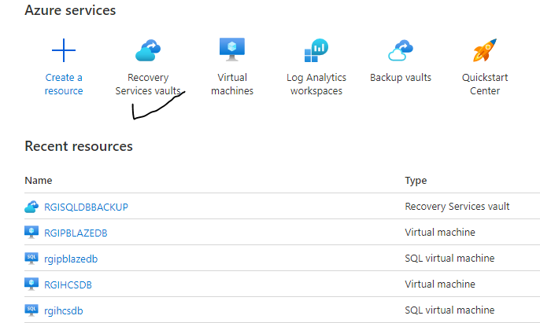

Step 3:

Click on RGISQLDBBACKUP PLEASE CHECK BELOW SCREENSHOT

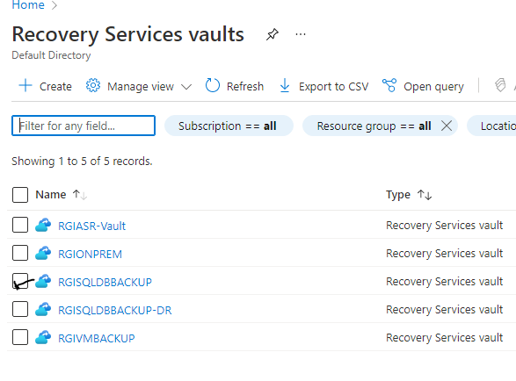

Step 4

click on BACKUP CHECK BELOW SCREENSHOT

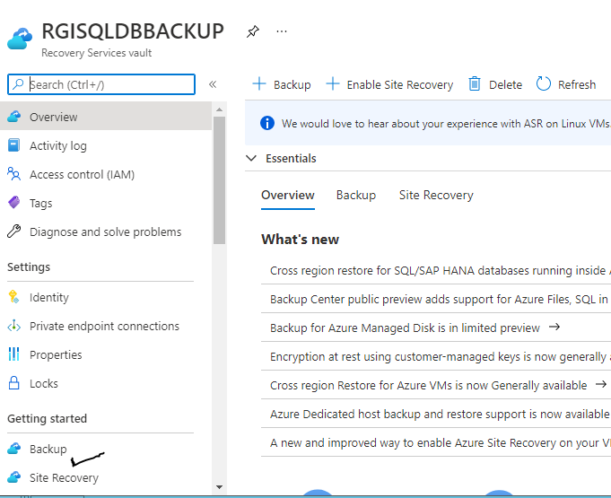

SETEP 5:

SELECT SQLSERVER IN AZURE VM

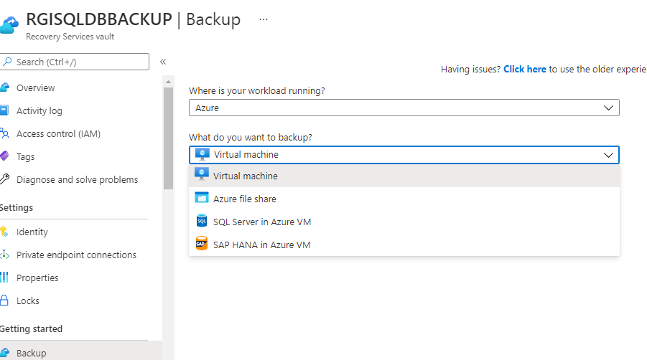

STEP 6:

CLECK ON VIEW DETAIL

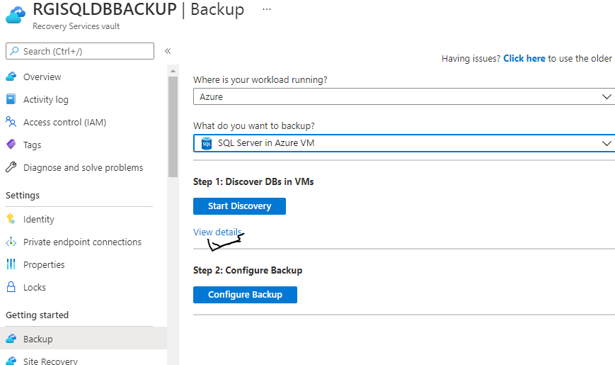

FIRST SERCH SERVER NAME FOR EXAMPLE RGISQLDB

IF ALREADY IS SERVER THERE

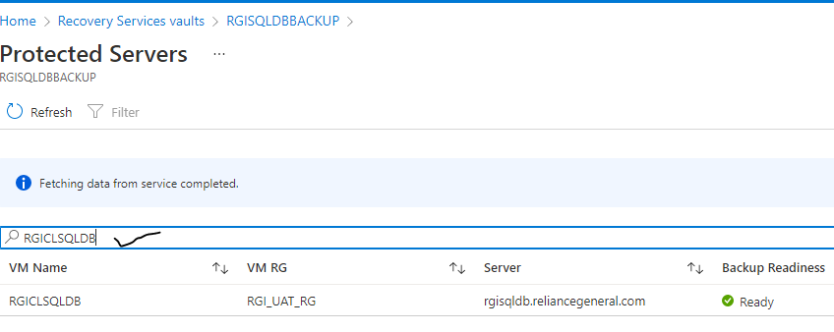

Step 7:

DELETE THE LOGIN NT SERVICE/AZUREWLBACKUPPLUGINSVC

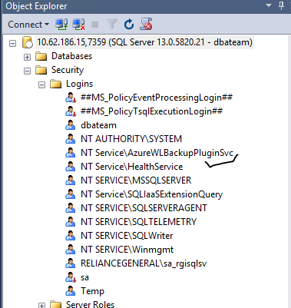

STEP 8 ERROR IS OCCOURED

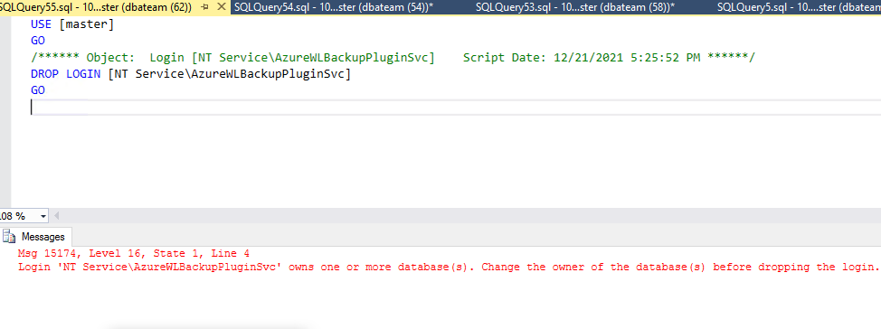

STEP 9

execute the query and check database name

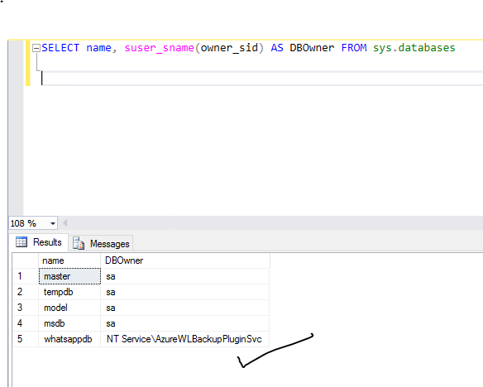

Step 10:

**sp_changerower** should **dbteam** only

and execute the query

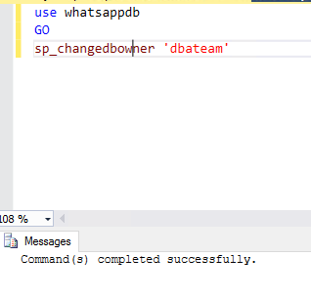

Step 11:

Drop the login. it is successfully drop

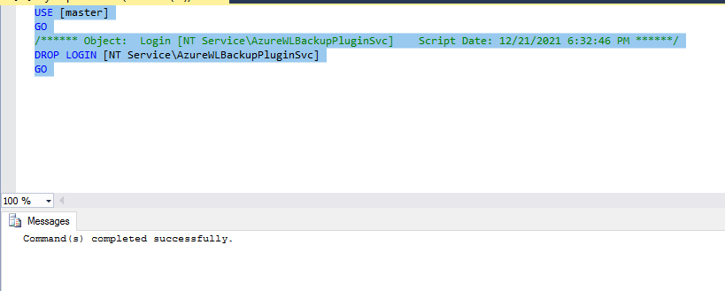

Step 12:

Click on un register

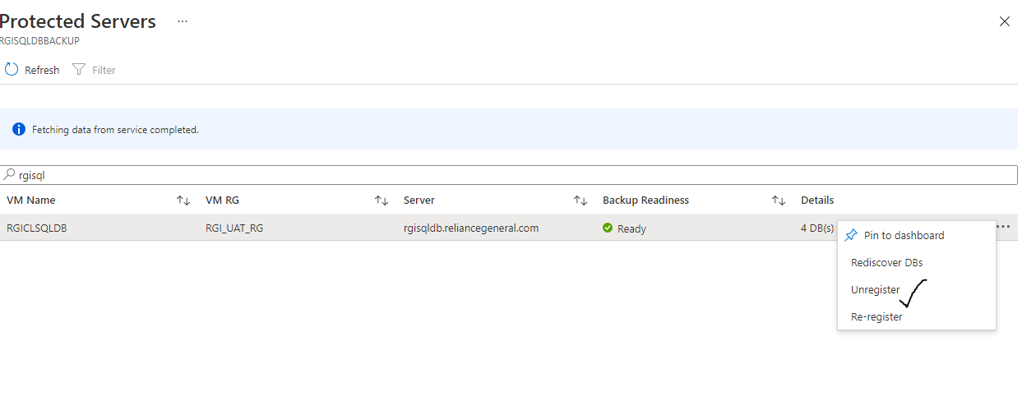

STEP 13:

Below screenshot giving reason why we are delete Rgisqldb

and fill it.



